Data Visualization Project

Project Theme: COVID-19 (or the virus, SARS-CoV-2)

Student : Ayten Tonbul

Number: 17030411012

In this period, the impact of the COVID-19 virus, which affects today's geography incredibly, on human behavior is unfortunately enormous. For this reason, I wanted to choose a topic that I can examine in the process of closing home, which is today's biggest problem. In order to observe what effect this social problem can have on human behavior, I will observe the twitch.tv data flow, which is a platform I have been in and had the opportunity to work on this platform recently, and I want to see how often people take part in this platform to have fun etc. In order to do this, I will narrow my observation area and examine the viewers of years and the sections that twitch has categorized and the broadcasters that have the majority of the audience. The reasons behind my desire to move in this direction are the large number of users, having a lot of data flow, being observable, appealing to the masses, the recent involvement of politicians and seeing this as a power for them, being able to follow increases or decreases and visually to be interpreted.

Here is some news ;

CNNTURK has included a news on this subject in technology news: “ If what you watch during the pandemic period mostly includes Twitch broadcasts, you are not alone. Streamlabs and Stream Hatchet have determined that Twitch views have more than doubled in a year, from 'only' 3.1 billion hours in the first quarter of 2020 to 6.3 billion in the same quarter in 2021 ... Twitch has already dominated live streaming, and it became even more important as musicians and other non-game creators flocked to the platform to replace face-to-face concerts and discussions. Even game-oriented publishers have more reasons to use Just Chatting. If they can't socialize face-to-face, they can also make money from virtual chats. Covid-19 seems to have worked for platforms in this respect. “

COVID-19: Twitch user increase 2020

Published by J. Clement, Jan 29, 2021

“ The COVID-19 pandemic that spread across the world at the beginning of 2020 was not only a big threat to public health, but also to the entire entertainment industry. While cinemas and theaters closed their doors to try to stem the spread of the disease, many people turned to home entertainment and eSports during periods of self-isolation. In March 2020, the online eSports streaming service Twitch set an all-time record of 22.7 million peak daily active users. “

TheVERGE

This is Twitch’s moment

By [Bijan Stephen](https://www.theverge.com/authors/bijan-stephen)  Mar 18, 2020

“…According to the streaming software company StreamElements — which conducts regular surveys of the streaming landscape with its analytics partner Arsenal.gg — viewership on Twitch is up. By a lot. Over the last week, it’s increased by a full 10 percent. As StreamElements CEO Doron Nir wrote in an email, that reflects “the popularity of the livestreaming medium now that people are consuming higher volumes of entertainment at home.” Translation: because we all have to stay inside now to flatten the coronavirus’s infection curve, everyone is watching stream..“

TWITCH: THE ULTIMATE COVID-19 BENEFICIARY

MCGILL'S STUDENT-RUN NEWS MAGAZINE

“…With the sudden influx of variety content on a previously game-dominated platform, Twitch recorded seventeen billion hours of views in 2020, which was an 83 percent increase compared to nine billion hours in 2019. “Just Chatting” emerged as the number one category, with major titles like League of Legends and Fortnite moving down the ladder. COVID-19 has created an interesting opportunity for streamers to capitalize on and I am genuinely looking forward to seeing how the live streaming industry develops and what new formats emerge in 2021, especially since it seems like we’ve still got a long way to go…“

Data Visuals :

I will use tracker system to collect data from twitch.tv .

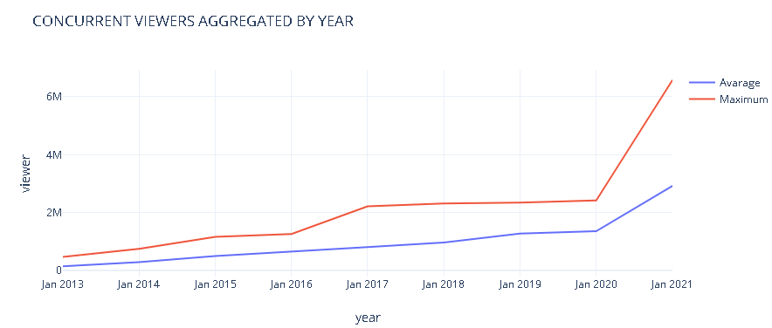

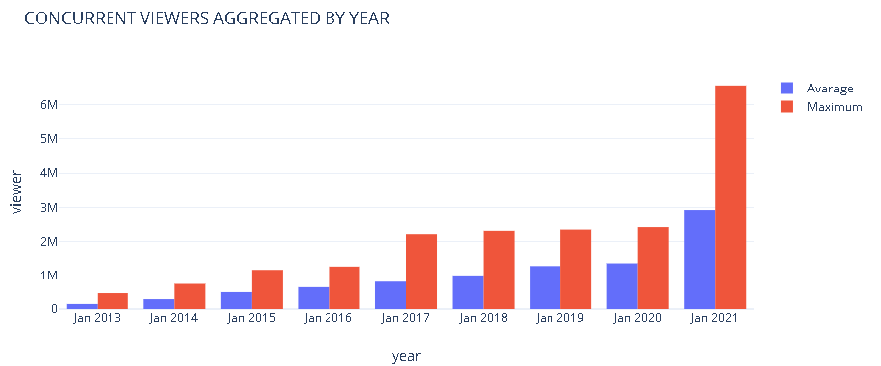

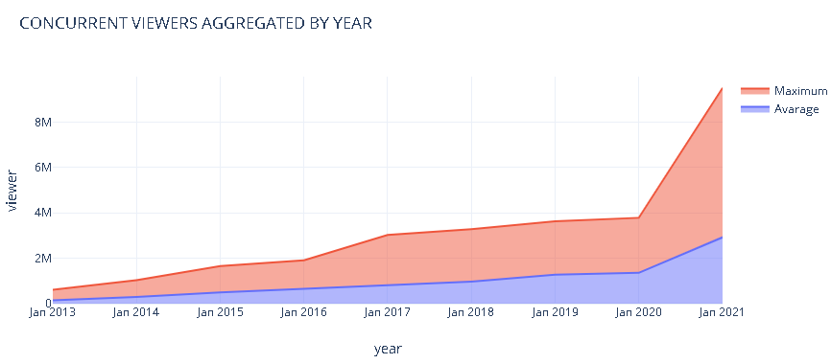

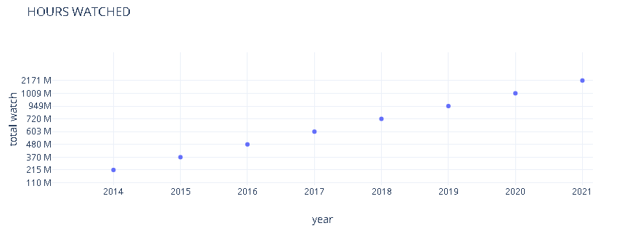

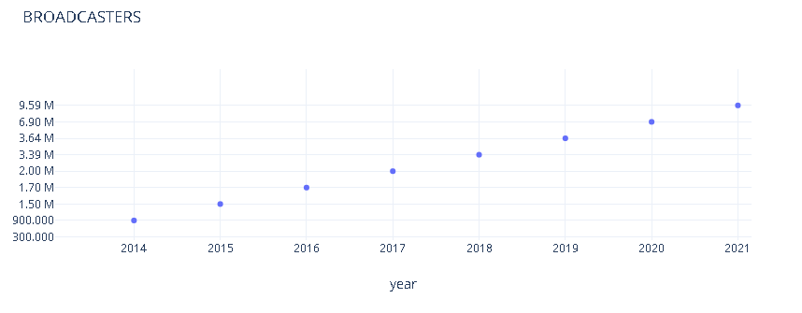

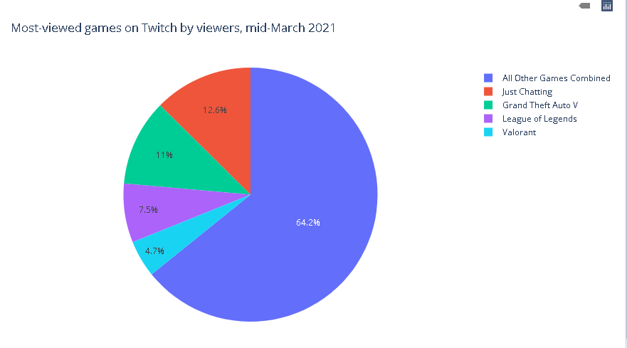

GeekWire

“…The biggest takeaway from the current data is that “Just Chatting” is here to stay. The category — a catch-all term for video logs, reality shows, unscripted programming, and streamers just hanging out with their audience — has grown rapidly over the last year, particularly as pandemic life has forced people all over the world into lockdown conditions. With a full 200 million hours watched on Twitch in October, Just Chatting is far and away the most popular category on the site, outstripping the gameplay-based content that Twitch is more typically known for… “

Insights from Visualizing Public Data on Twitch

Mapping Communities Using Viewer Trends

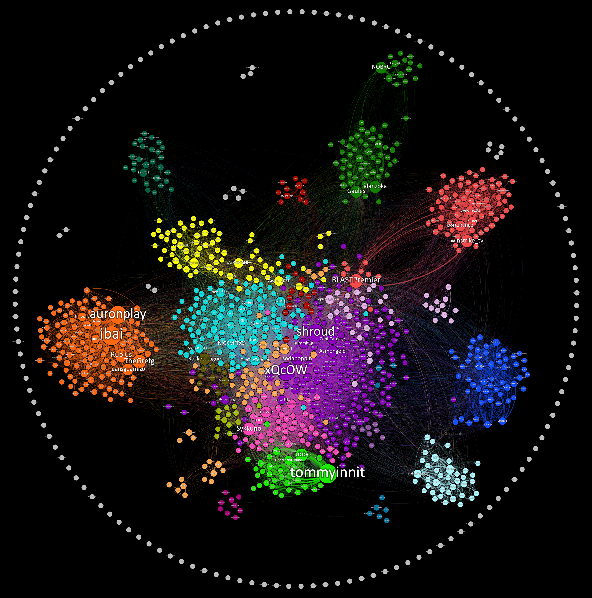

*Kiran Gershenfeld- Tool : Gephi*

Resources

<https://www.statista.com/statistics/1108340/covid-twitch-users>

https://www.cnnturk.com/teknoloji/twitch-izlenme-sayisini-katladi

<https://chart-studio.plotly.com/create/>

<https://www.businessofapps.com/data/twitch-statistics/>

<https://www.geekwire.com/2020/twitch-sets-audience-record-october-pandemic-continues-fuel-livestreaming-growth/>

<https://twitchtracker.com/statistics/games>

https://towardsdatascience.com/insights-from-visualizing-public-data-on-twitch-a73304a1b3eb